University of Engineering and Technology, Lahore
Computer Engineering Department
Java Programming Lab
50 Practice Tasks: Basic to Critical Thinking
Name: Muhammad suvaid dawar Roll No: 2026(S)CYS50 Date: 10/19/2026

Equipment Required:

IntelliJ IDEA Community Edition, NetBeans with JDK 13, Visual Studio.

Theory / Relevant Material:

Objects and classes, constructors, getters and setters, modifiers.

Task 1: dayType Class
Problem Statement
Design and implement a class dayType that implements the day of the week in a program. The class should store the day, such as Sun for Sunday, and perform the following operations on an object of type dayType: (a) set the day, (b) print the day, (c) return the day, (d) return the next day, (e) return the previous day, (f) calculate and return the day by adding certain days to the current day. For example, if the current day is Monday and we add 4 days, the day returned is Friday. If today is Tuesday and we add 13 days, the day returned is Monday.
Approach
The days are kept in a private array (Sun to Sat) and the current day is stored as a private index. Next, previous and add-days use modulo 7 arithmetic so the week wraps around. setDay() accepts both short and full names (Mon or Monday) in any case and throws an exception for invalid input.
Source Code (DayTypeDemo.java):

class DayType {
private static final String[] DAYS = {"Sun", "Mon", "Tue", "Wed", "Thu", "Fri", "Sat"};
private int dayIndex;

public DayType() {
dayIndex = 0;
}

public DayType(String day) {
setDay(day);
}

public void setDay(String day) {
String key = day.trim().toLowerCase();
if (key.length() < 3) {
throw new IllegalArgumentException("Invalid day: " + day);
}
for (int i = 0; i < DAYS.length; i++) {
if (key.startsWith(DAYS[i].toLowerCase())) {
dayIndex = i;
return;
}
}
throw new IllegalArgumentException("Invalid day: " + day);
}

public void printDay() {
System.out.println("Day: " + DAYS[dayIndex]);
}

public String getDay() {
return DAYS[dayIndex];
}

public String nextDay() {
return DAYS[(dayIndex + 1) % 7];
}

public String previousDay() {
return DAYS[(dayIndex + 6) % 7];
}

public String addDays(int n) {
int idx = ((dayIndex + n) % 7 + 7) % 7;
return DAYS[idx];
}
}

public class DayTypeDemo {
public static void main(String[] args) {
DayType d = new DayType();
d.setDay("Mon");
d.printDay();
System.out.println("Return day: " + d.getDay());
System.out.println("Next day: " + d.nextDay());
System.out.println("Previous day: " + d.previousDay());
System.out.println("Mon + 4 days = " + d.addDays(4));

d.setDay("Tue");
System.out.println("Tue + 13 days = " + d.addDays(13));
}
}

Output:
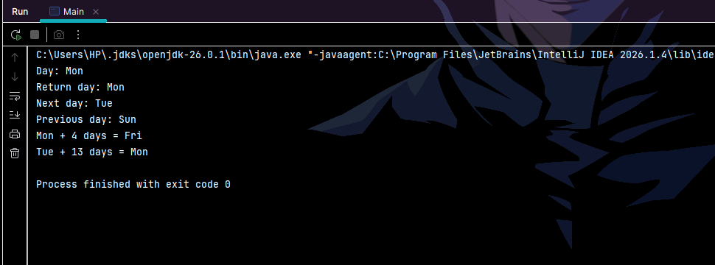

Task 2: Walls Ice Cream Class
Problem Statement
Walls sells ice cream in 7 flavors: chocolate, vanilla, strawberry, mango, tutti fruit, almond crunch, and coffee. Create a Walls class with flavor, number of scoops, cone type, and price fields. If no arguments are supplied, the flavor defaults to Vanilla, the number of scoops to 1, and the cone type to Sugar. The constructor calculates the price based on Rs. 75 per scoop, with an additional Rs. 40 for a waffle cone. A switch/if statement is used in main() to ask the user for flavor, scoops, and cone type.
Approach
The no-argument constructor calls the parameterized constructor using this("Vanilla", 1, "Sugar"). The parameterized constructor computes the price as scoops x 75, and adds 40 if the cone is Waffle. All fields are private and exposed through getters. main() uses switch statements to read the flavor and cone type from the user, with defaults for invalid input.
Source Code (WallsDemo.java)

import java.util.Scanner;

class Walls {
private String flavor;
private int scoops;
private String coneType;
private int price;

private static final int PRICE_PER_SCOOP = 75;
private static final int WAFFLE_EXTRA = 40;

public Walls() {
this("Vanilla", 1, "Sugar");
}

public Walls(String flavor, int scoops, String coneType) {
this.flavor = flavor;
this.scoops = scoops;
this.coneType = coneType;
this.price = scoops * PRICE_PER_SCOOP;
if (coneType.equalsIgnoreCase("Waffle")) {
this.price += WAFFLE_EXTRA;
}
}

public String getFlavor() { return flavor; }
public int getScoops() { return scoops; }
public String getConeType() { return coneType; }
public int getPrice() { return price; }

public void display() {
System.out.println("Flavor : " + flavor);
System.out.println("Scoops : " + scoops);
System.out.println("Cone : " + coneType);
System.out.println("Price : Rs. " + price);
}
}

public class WallsDemo {
public static void main(String[] args) {
Scanner sc = new Scanner(System.in);

System.out.println("Flavors:");
System.out.println("1. Chocolate");
System.out.println("2. Vanilla");
System.out.println("3. Strawberry");
System.out.println("4. Mango");
System.out.println("5. Tutti Fruit");
System.out.println("6. Almond Crunch");
System.out.println("7. Coffee");
System.out.print("Choose flavor (1-7): ");
int f = sc.nextInt();

String flavor;
switch (f) {
case 1: flavor = "Chocolate"; break;
case 2: flavor = "Vanilla"; break;
case 3: flavor = "Strawberry"; break;
case 4: flavor = "Mango"; break;
case 5: flavor = "Tutti Fruit"; break;
case 6: flavor = "Almond Crunch"; break;
case 7: flavor = "Coffee"; break;
default:
System.out.println("Invalid flavor, using default (Vanilla).");
flavor = "Vanilla";
}

System.out.print("Number of scoops: ");
int scoops = sc.nextInt();
if (scoops < 1) {
System.out.println("Invalid scoops, using 1.");
scoops = 1;
}

System.out.print("Cone type (1 = Sugar, 2 = Waffle): ");
int c = sc.nextInt();
String cone;
switch (c) {
case 2: cone = "Waffle"; break;
case 1: cone = "Sugar"; break;
default:
System.out.println("Invalid cone, using Sugar.");
cone = "Sugar";
}

System.out.println("\n--- Your Order ---");
new Walls(flavor, scoops, cone).display();

System.out.println("\n--- Default Order ---");
new Walls().display();

sc.close();
}
}
Output:

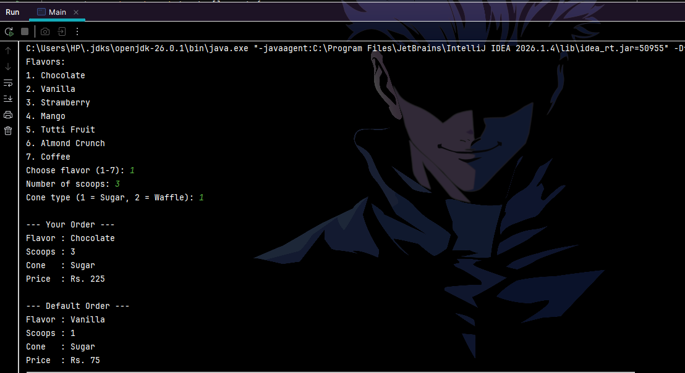

Task 3: Product Class
Problem Statement
Create a class named Product with private members name (String), price (int) and quantity (int). Define a parameter-less and a parameterized constructor, and the member functions void getData(), static void counter() and static int countProduct(). The class contains a static int totalProduct with initial value zero. Each time an instance of Product is created, counter() should be called, which increments the static member by 1. If 5 products are created, the program should display 5.
Approach
Both constructors call counter(), which increments the static variable totalProduct. countProduct() returns its value, so it is called through the class name (Product.countProduct()). getData() reads the name, price and quantity from the user. A display() method is added to print the product details.
Source Code (ProductDemo.java)

import java.util.Scanner;

class Product {
private String name;
private int price;
private int quantity;

private static int totalProduct = 0;

public Product() {
name = "Unknown";
price = 0;
quantity = 0;
counter();
}

public Product(String name, int price, int quantity) {
this.name = name;
this.price = price;
this.quantity = quantity;
counter();
}

public void getData() {
Scanner sc = new Scanner(System.in);
System.out.print("Enter name: ");
name = sc.nextLine();
System.out.print("Enter price: ");
price = sc.nextInt();
System.out.print("Enter quantity: ");
quantity = sc.nextInt();
}

public void display() {
System.out.println("Name: " + name + ", Price: " + price + ", Quantity: " + quantity);
}

public static void counter() {
totalProduct++;
}

public static int countProduct() {
return totalProduct;
}
}

public class ProductDemo {
public static void main(String[] args) {
Product p1 = new Product();
Product p2 = new Product("Pen", 20, 100);
Product p3 = new Product("Notebook", 150, 50);
Product p4 = new Product("Bag", 1200, 10);
Product p5 = new Product();

p1.display();
p2.display();
p3.display();
p4.display();
p5.display();

System.out.println("Total products: " + Product.countProduct());
}
}
Output:
